Issues on the Radio Magagement and Service Guide for the 9th Asian Winter Games Harbin 2025

Department of Industry and Information Technology of Heilongjiang Province

The 9th Asian Winter Games Harbin 2025 Organising Committee

CONTENTS

Frequently Asked Question and Service Guide p1

Pattern of Radio Frequency Licence
for the 9th Asian Winter Games Harbin 2025 p15

Pattern of Radio Transmission Equipment Dedicated Tag
for the 9th Asian Winter Games Harbin 2025 p16

Frequently Asked Question and Service Guide

Laws and Regulations
During the preparation and Harbin 2025 Games, what laws and regulations should I abide by when using radio transmission equipment in the Harbin 2025 venues and special control areas?
Any organisation or individual intending to use radio frequencies, establish and operate radio stations, and use radio transmission equipment and non-radio equipment that radiates radio waves in the Harbin 2025 venues located in Downtown Harbin and the Yabuli Competition Zone (hereinafter referred to as "the Games venues") and special control areas (designated by HAWGOC) shall abide by the Radio Regulations of the People’s Republic of China, Regulations of the People's Republic of China on Radio Control and other corresponding laws and regulations, as well as this Notice.

Equipment Management
During the preparation and Harbin 2025 Games, what procedures should I follow if I intend to use radio transmission equipment in the Games venues and special control areas?
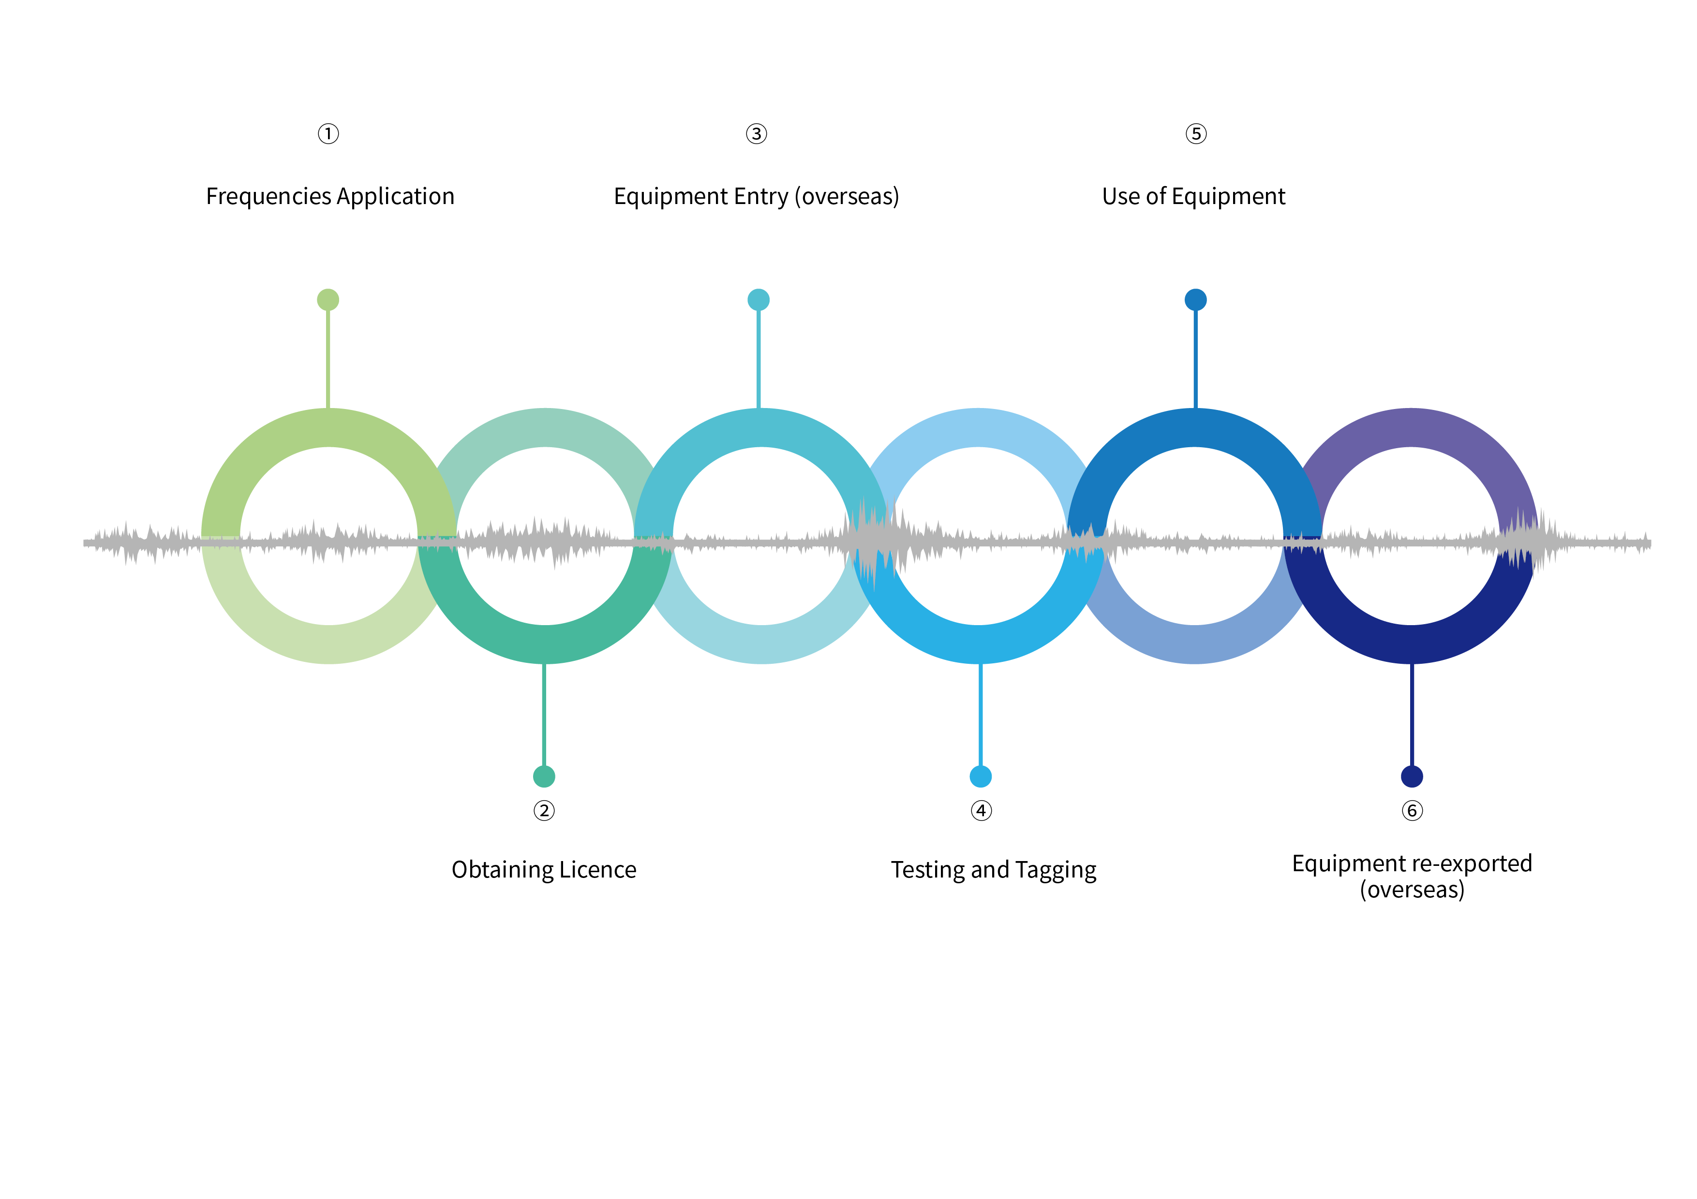
What kind of equipment can be used in the Games venues and special control areas without frequency spectrum application?
The following equipment can be used in the Games venues and special control areas are exempt from radio frequency application and requirement for Dedicated Tags while the safety and security regulations of the Games venues and special control areas should still be observed, and the equipment must not be used as wireless LAN hotspots or have their Bluetooth function enabled: public mobile communication terminals (mobile phones); wireless internet cards; laptops; tablet computers; car remote keys and camera wireless remote control devices with power below 2mW; and personal biomedical telemetry and medical implantation and related supporting equipment, smart watches, smart bracelets, Bluetooth headsets and other wearable smart devices that conforming to the technical requirements of micro-power short-range radio transmission equipment (excluding wireless microphones, cordless phones, wireless remote control devices and public walkie-talkies).Radio equipment exempt from testing and tagging is shown as below.
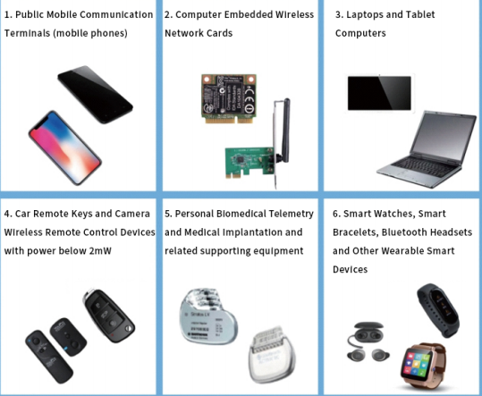
Does non-radio equipment radiating radio waves to be used in the Games venues and special control areas require radio frequency applications?
It is important to note that, non-radio equipment that radiates radio waves, such as large screens, uninterruptible power supplies (UPSs) and microwave heating equipment with a rated power of 3kW or above, do not require radio frequency application. However, before entering the Games venues and special control areas, its use should be reported to the IT Department of HAWGOC (e-mail: spectrum@harbin2025.com), and a surrounding electromagnetic environment testing needs to be conducted by the radio management authority.

Frequencies Application
How to apply for a radio frequencies?
Domestic and international users can submit the application on the Spectrum Order Portal (SOP,https://spectrum.harbin2025.com/ ).
There are three stages in the radio frequency application schedule of the Harbin 2025.
1. The normal application stage (first stage) is from 31 August 2024 to 20 October 2024. The availability of application and the probability of obtaining approval are very high during this stage. Approval for radio frequency applications in this stage will be issued before 12 January 2025.
2. The late application stage (second stage) is from 28 October 2024 to 12 January 2025. Applications received in this stage will be approved on a first-come and first-served basis when radio frequency resources are available. The availability of the radio frequency application in this stage is lower than in the first stage. If the frequency resource is limited, the probability to obtain the approval is very low. Approval for frequency application in this stage will be issued before 27 January 2025.
3. The extraordinary application stage (third stage) is from 27 January to 14 February 2025. This stage is only used for emergency applications for important frequency requirements during Harbin 2025. Since most of the radio frequency resources have been allocated before this stage, demand for frequencies cannot be satisfied directly. Therefore, it is not recommended to submit an application during this stage except for an emergency application required to ensure the smooth progress of the Games and broadcast. Approval for frequency application in the third stage will be issued as soon as possible based on the availability of spectrum resources, technical analysis and the complexity of any necessary adjustments.

How could international organisations and individuals enjoying diplomatic privileges and immunities apply for setting up and operating radio stations or radio transmission equipment in the Games venues and special control areas?
Foreign leaders, embassies and consulates in China, and international organisations and individuals enjoying diplomatic privileges and immunities, if having the demand for setting up and operating radio stations, they should apply to the Radio Regulation Bureau of MIIT of the People’s Republic of China for approval diplomatically. Users of satellite earth stations (including fixed and mobile satellite earth stations) shall apply for Frequency Licence from the Radio Regulation Bureau of MIIT.

If the equipment will be used in several venues, can I apply for frequency in the same time?
Each submission can only include application information for the same frequency and maximum 10 different venues/locations. If the equipment will be used in more than 10 venues/locations, please submit a separate application.

Will all my frequency applications be approved?
Not necessarily. Considering the large number of radio equipment and stations will be used during the Games venues and special control areas during the Games, and the available radio frequency resources are very limited, there is the possibility that you could not get the approval. If the Licenced frequency is not the same as the preferred centr frequency in your application, you need to change the technical parameters of your radio transmission equipment in according with the Frequency Licence (the Licenced centr frequency will be selected within the tunable frequency range). The equipment shall not be used in the Games venues and special control areas, if the parameters could not be configured correctly. Therefore, it is important to ensure the accuracy of application information.
Specifically, except for special requirement, it is strongly recommended that users access the WLAN network provided by HAWGOC or by mobile communication operators, and the frequency applications for private WLAN access point or hotspots will not be approved.

If I have any questions during the application, how to consult?
If there are questions about the frequency application process, you can seek assistance through the following ways:
E-mail: spectrum@harbin2025.com
Domestic users can also call the Tel. Number 18345157491 for consultation.

Licence obtaining
How can I get the Frequency Licence after obtaining the approval?
After having obtained the Radio Frequency Licence for Harbin 2025, you can download and print the electronic version on SOP or through the registered email.

Entry and Exit of the Equipment
As overseas users, how can I go through temporary entry procedures of radio stations and radio transmission equipment?
During this period, overseas users who need to set up and use radio stations and radio transmission equipment in the Games venues and special control areas, shall go through temporary entry procedures for such equipment, and submit printed copies of the Letter of Approval for Temporary Import of Radio Transmission Equipment and other required materials to the Customs of the People's Republic of China. The temporarily imported radio stations and radio transmission equipment shall be re-exported on schedule.

Testing and Tagging
What should I do after getting the Licence?
Users having obtained the Licence should send the radio stations and radio transmission equipment to the designated location for radio frequency parameters before taking them to the Games venues or special control areas. Verified equipment will be affixed with a Dedicated Tag. For equipment that is inconvenient to move, users can make a reservation for on-site verification through the SOP or via e-mail.

What are the procedures of testing and tagging for Harbin 2025?
The basic procedures are as follows:
- Users should obtain the Frequency Licence before the testing and tagging, and ensure that the radio equipment have been configured with technical parameters in accordance with the Frequency Licence.
2. Users should make a reservation for testing and tagging with the designated testing agency. The specific contact information for reservation can be found via SOP or in the 9th Asian Winter Games Harbin 2025 Radio Transmission Equipment Verification and Tagging Guide.
3. After receiving the reservation, the testing agency will arrange technical team nearby to carry out the work of testing and tagging according to actual situation, and confirm the time and location for testing with the applicant via e-mail or phone calls. For large radio stations and radio transmission equipment that are not portable, users should add a special note in the reservation and negotiate with the testing agency for other appropriate approach such as on-site verification.
4. Users should take the following equipment and documents to the testing and tagging site: radio transmission equipment, printed copies of the Frequency Licence or the Licence number, personal identification of the handler and letter of authorisation from responsible organisations. Prior to testing and tagging, equipment should be fully charged and be configured with necessary power supply, cable and other accessories.
5. Radio stations and equipment verified by the testing agency will be pasted with a Dedicated Tag.

How can I make the reservation for testing and tagging?
Domestic and overseas users who have obtained the Frequency Licence shall make a reservation for verification in advance through the SOP or via e-mail. The testing and tagging procedures will be arranged according to the received reservation order.
The reservation procedure will apply in the Downtown Harbin Competition Zone and the Yabuli Competition Zone, you do not need to go to a specific location for reservation in person. Users will be promptly notified of the reservation results via e-mail or phone calls.
Contact: Wang Chao;
Tel: +86-0451-58680799；13354507712
E-mail: radiotest2025@163.com

What are the locations for testing and tagging?
It is planned to set up 6 inspection points for equipment verification and labeling, and the specific locations for testing and tagging will be published on the Spectrum Order Portal of Asian Winter Games Harbin.

What’s the quantity of equipment that I should prepare for testing and tagging?
It is generally required that at least one device per user shall be tested, no less than 20% of all WLAN devices applied for shall be tested, no less than 10% of other devices applied for shall be tested, and all wireless microphones shall be tested.

Is there any requirement for using the Dedicated Tag?
Radio stations and equipment verified by the testing agency can be used in the Games venues or special control areas after being pasted the Dedicated Tag. These stations and equipment must be used within the specific timeframe specified on the Frequency Licence. The tag obtained shall be affixed to a visible location on the stations and equipment, and abide by the venue's security inspection and equipment entry verification process. Each tag with a unique serial number can only be matched to the corresponding equipment, and shall not be misappropriated or applied without authorisation. You need to sign a Tag Usage Undertaking when getting the Dedicated Tags.

If I lost my Dedicated Tags, what should I do?
You can contact the testing point where your Dedicated Tags were previously issued and explain the situation. After verifying, there will be a replacement of tags and the previous tags will become invalid. If it is inconvenient to go to the previous testing point, please contact the testing agency staff via the e-mail or phone calls to help you make the replacement nearby.

Use of the Equipment
What should I do when radio interference is caused to my radio stations or radio transmission equipment that are legally set up and used in the Games venues and special control areas?
When radio interference occurs with radio stations or radio transmission equipment that are legally set up and used in the Games venues and special control areas, users can report the interference to the Venue IT Help Desk, Venue IT Director, or the Department of Industry and Information Technology (DIIT) of Heilongjiang Province. The relevant departments of HAWGOC and the DIIT of Heilongjiang Province will promptly coordinate and handle any complaints regarding radio interference, and will inform you of the handling progress and results.

Is there any notice for applying for radio frequencies, setting up and using radio equipment during the Games?
Please note:
1. The user information and technical details must be accurate;
2. When using the approved radio frequency, the equipment must work in accordance with the parameters stated in the Frequency Licence, and the frequency, bandwidth, power, equipment model, usage area, usage time, business purpose and other content cannot be changed without authorization;
3. The approved radio frequency shall not be transferred;
4. Users shall take the initiative to handle radio equipment testing and tagging before using the radio equipment. Radio equipment without Dedicated Tag shall not be brought into or be used in the Games venues and special control areas, nor be used;
5. Users shall consciously abide by the revelant laws and regulations of China’s radio management, and actively cooperate with the supervision and inspection of the radio frequency authorities. Those who violate the relevant regulations of radio management will be punished according to related law.

Pattern of Radio Frequency Licence for the 9th Asian Winter Games Harbin 2025

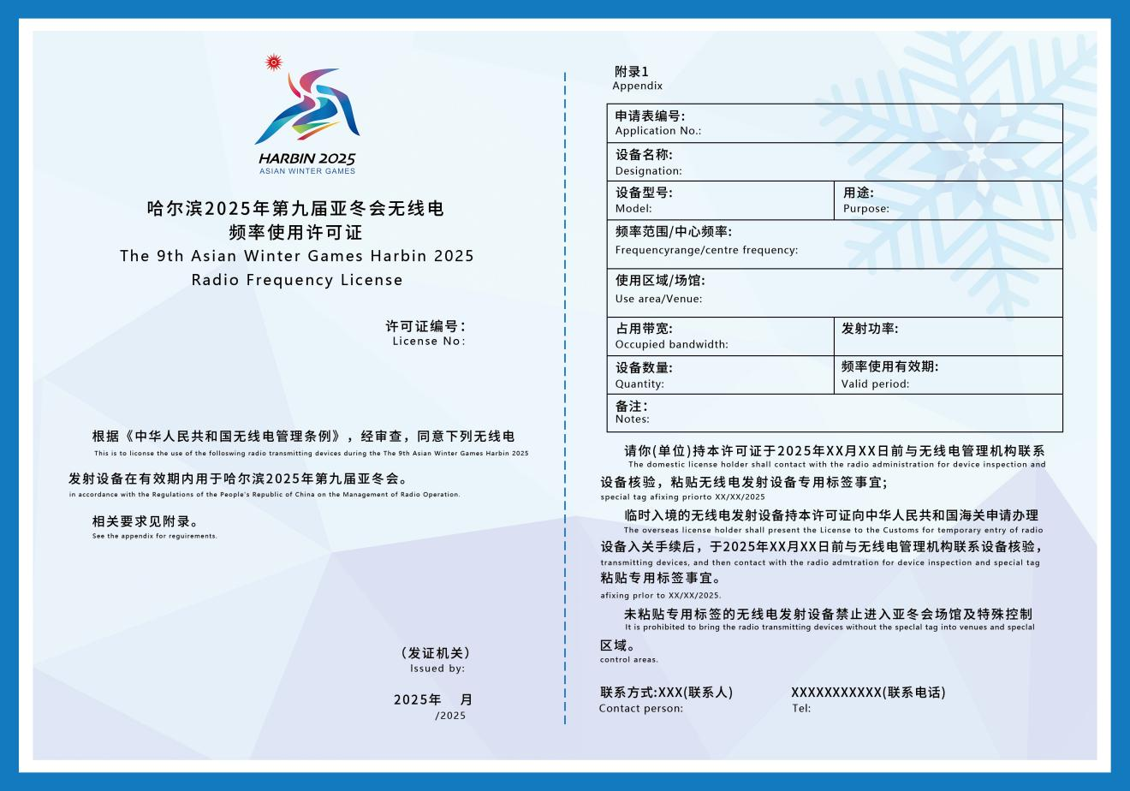

Pattern of Radio Transmission Equipment Dedicated Tag for the 9th Asian Winter Games Harbin 2025
The Dedicated Tag has two sizes:
Circular Tag Size: 3cm*3cm Square Tag Size: 4.5cm*2.7cm
