# Examples of Radio Transmission Equipment to be Pasted with Radio Transmission Equipment Dedicated Tag During the Harbin 2025 and Its Preparation Period

1. Land Mobile Radio

Mainly used for communication between staff and personnel command and dispatch, etc., so as to enhance communication efficiency and quick response to emergencies in the venues.

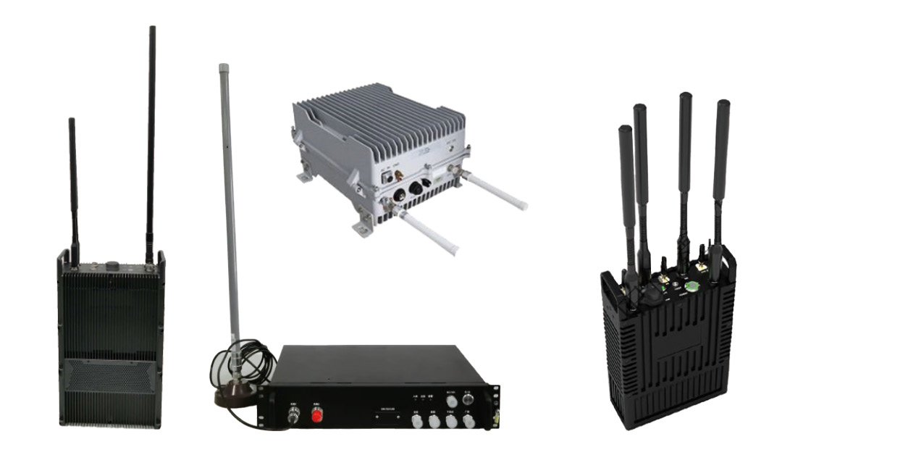

2. Handheld Radios (walkie-talkie)

Mainly used for communication between staff and personnel command and dispatch, etc., so as to enhance communication efficiency and quick response to emergencies in the venues.

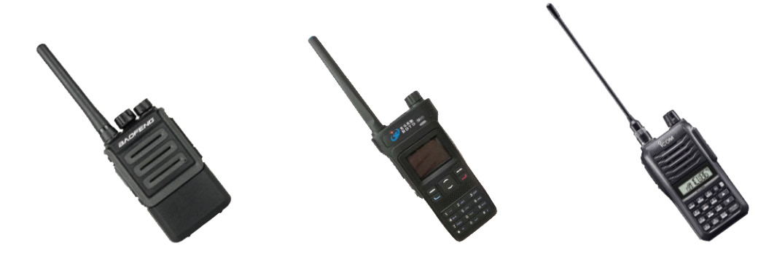

3. Wireless Camera

Mainly used for recording and shooting of the game scenes in competition venues and also for transmitting the recorded video to the user terminal.

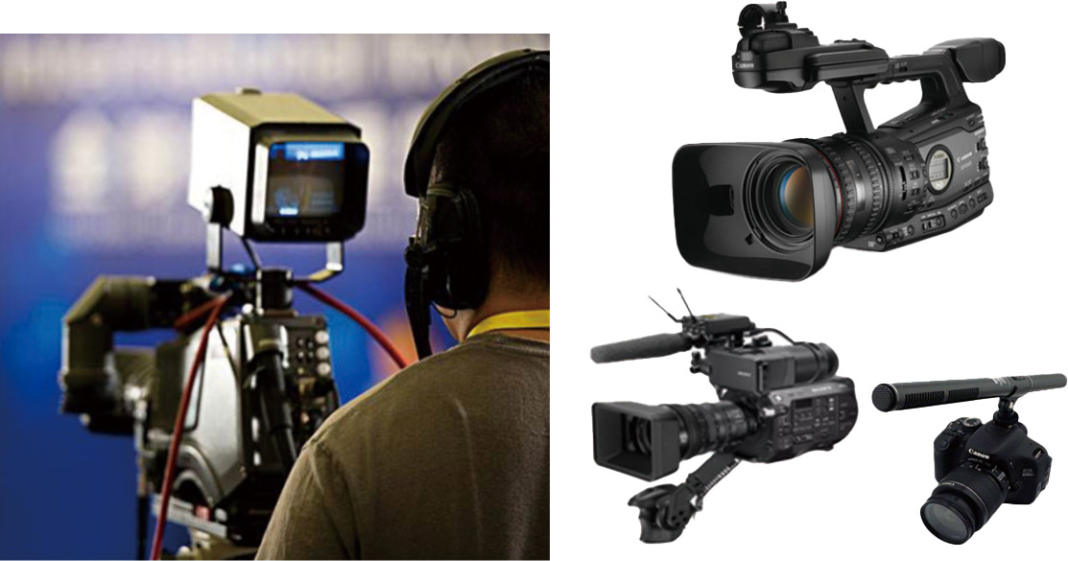

4. Wireless Microphone

Mainly used by staff in the competition venues to announce competition matters.

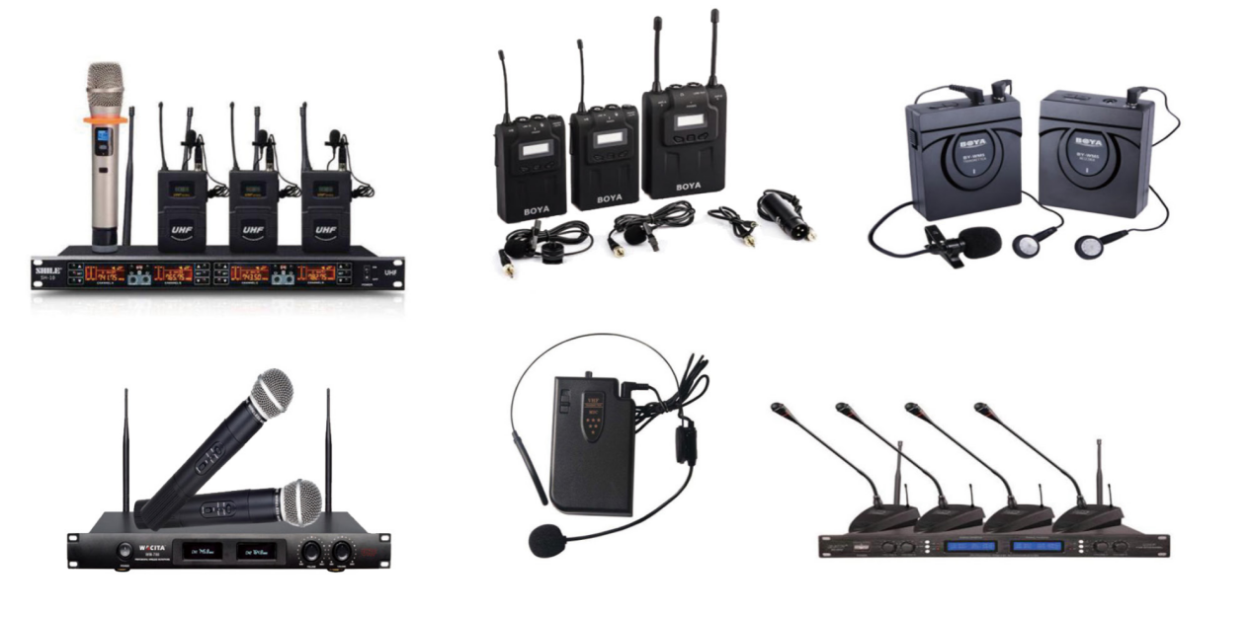

5. Telemetry and Telecommand

Mainly used for remote control and measurement.

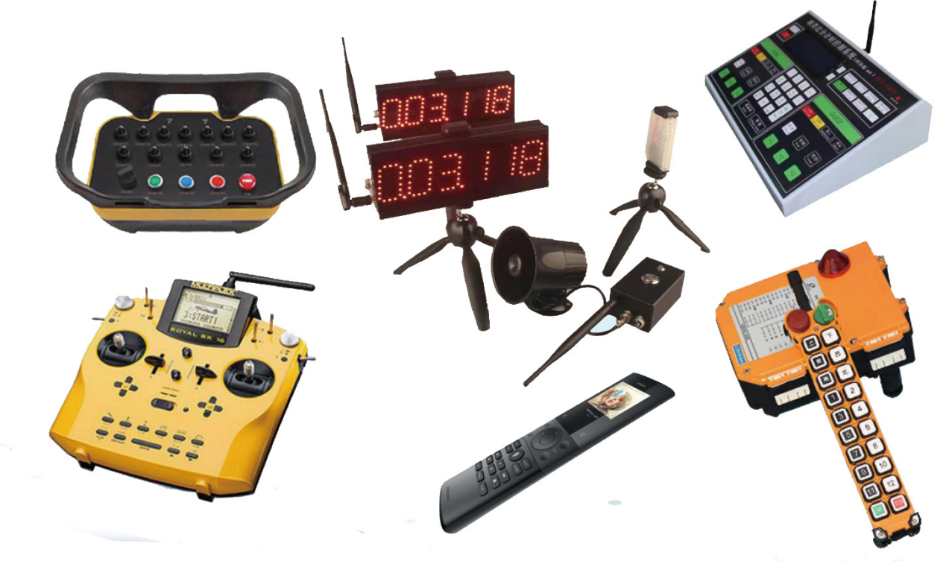

6. In-ear Monitoring systemMainly used by staff for one-way receiving live broadcast, commanding and dispatching and sound effects.

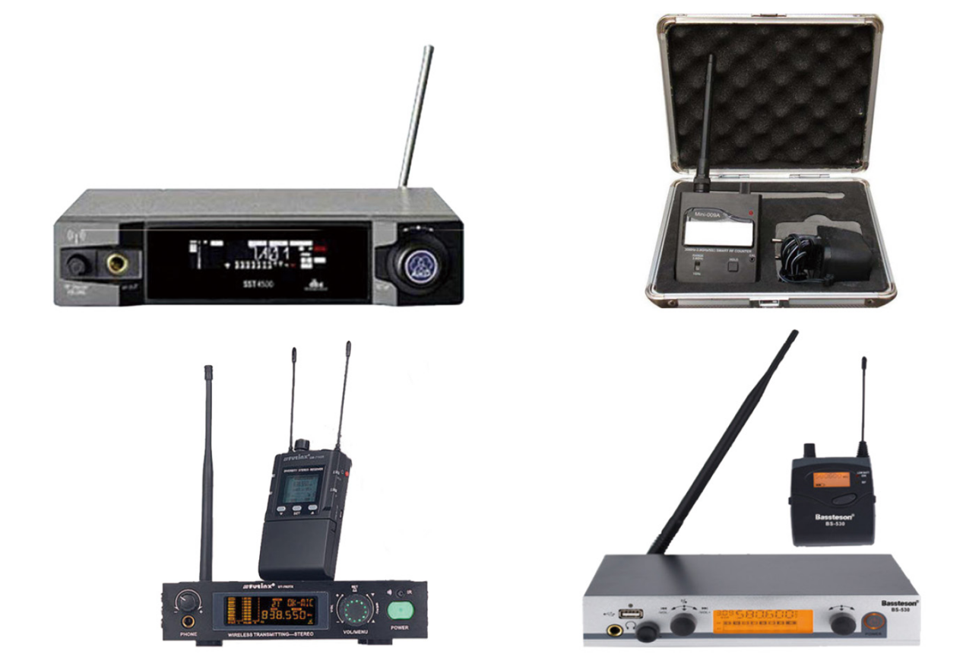

7. Wireless LAN and Bluetooth

Mainly used for Internet transmission of the staff in the competition venues and for wireless Internet access of spectators to share the games with others.

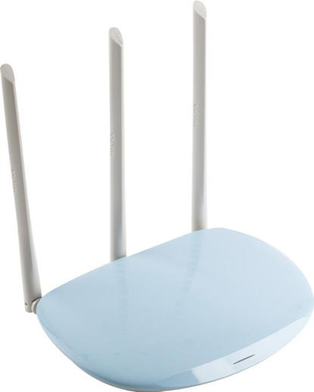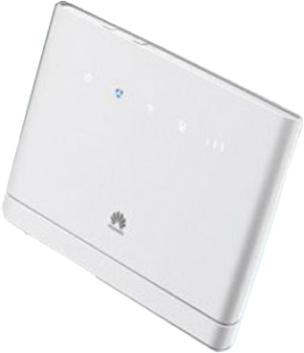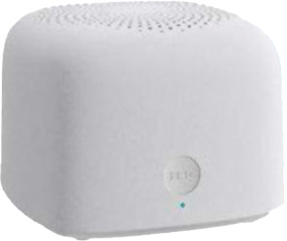

8. Microwave Fixed Link

Used in the competition venues to return video, voice and data in a point-to-point or point-to-multipoint manner, and to transmit the video, voice and data of the games scenes to the user terminal.

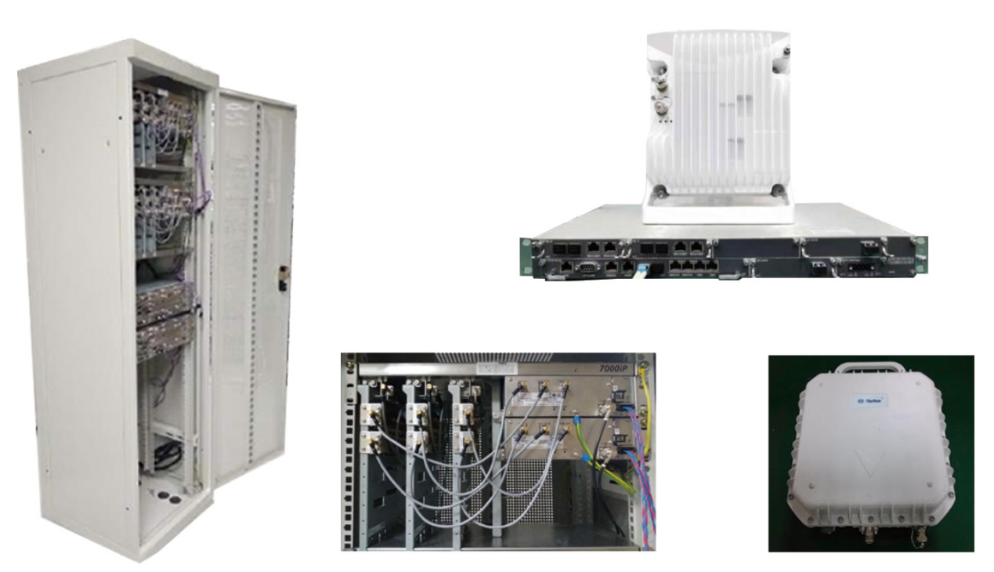

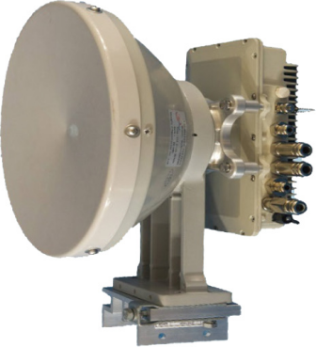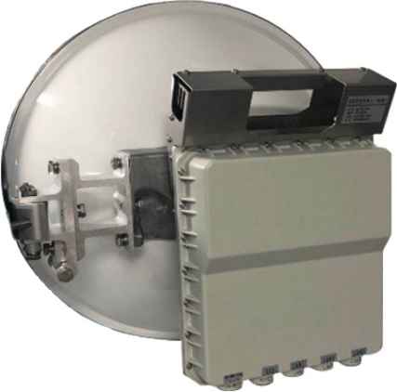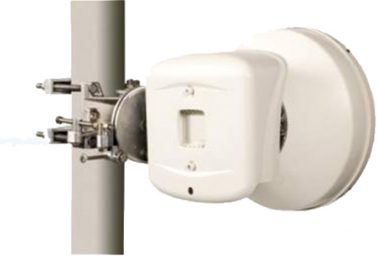

9. Microwave Mobile Link

Used for communication guarantee for emergencies within competition venues, quickly establishing a backup communication network through the mobile microwave link and transmitting video, voice and data of the game scenes to the user terminal.

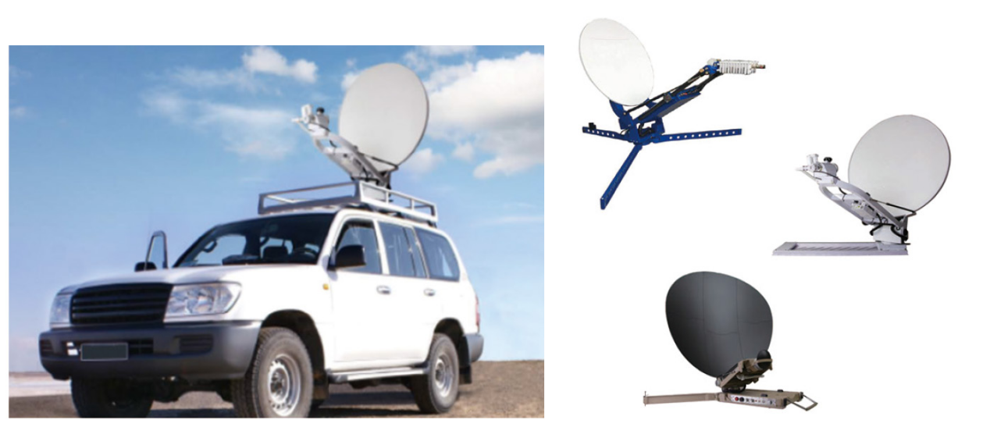

10. Fixed Earth Station

The audio, video, data and other information collected by the camera in the venues will be sent to the satellite through a fixed satellite link. The satellite will send the collected information to a ground information processing station who will then send the audio, video and data to a client.

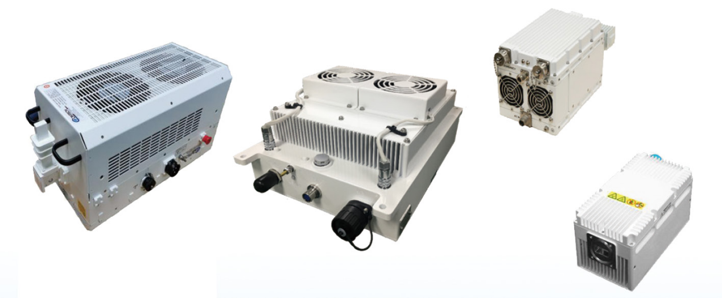

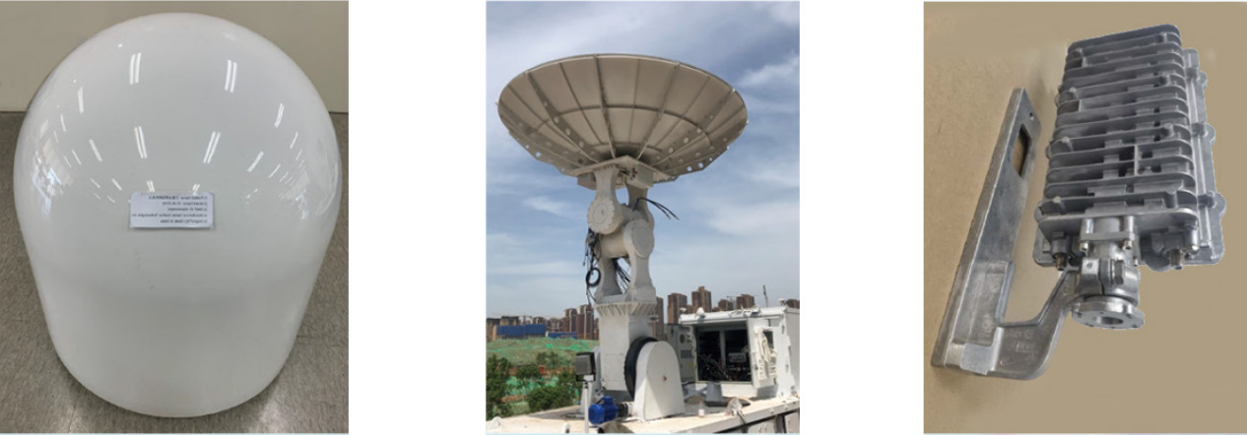

11. Mobile Earth Station

Mobile satellite links will be used to quickly transmit live video, voice and data to a satellite outside competition venues or in remote areas. The satellite will send the collected information to the ground information processing station who will then send the audio, video, data and other information to a client.

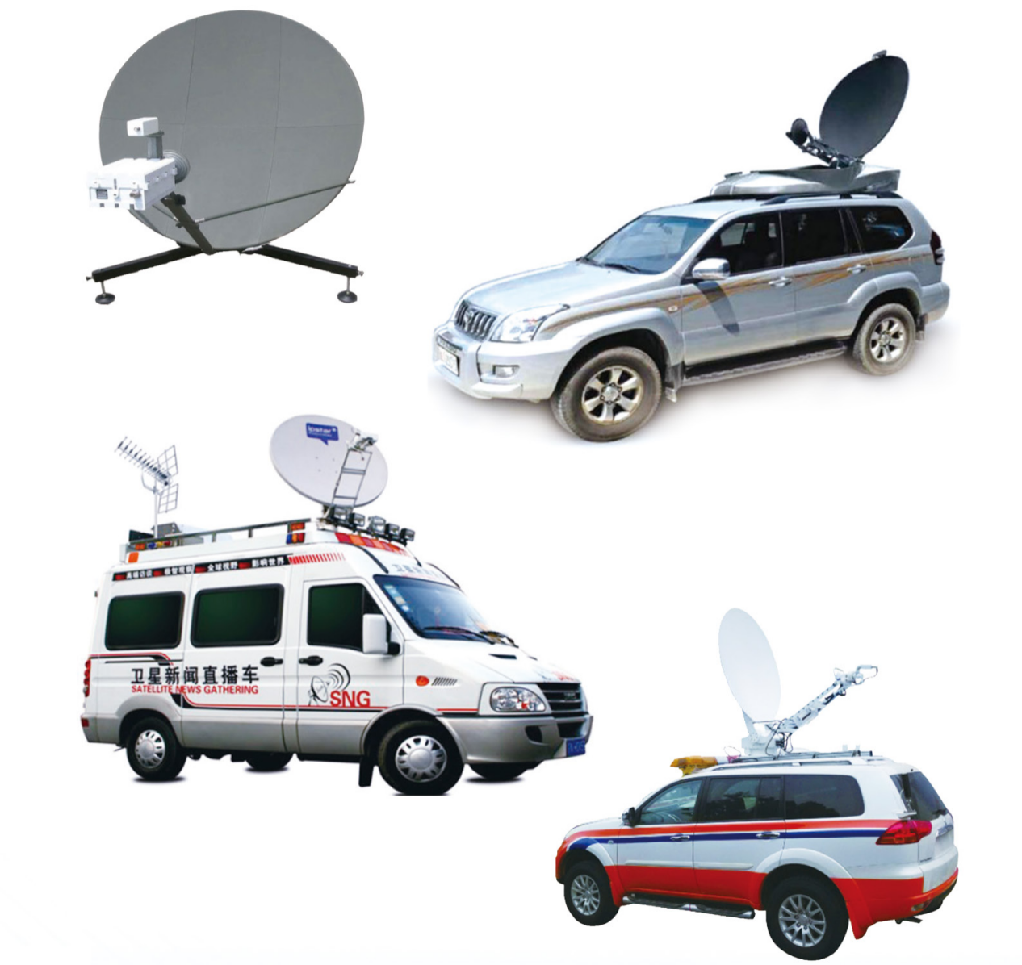

12. Others

Mainly used for safety monitoring within competition venues, including personnel flow, equipment safety, etc.

